**Variational AutoEncoders**

**Latest Submission Grade 100%**

**1.**

**Question 1**

For Variational AutoEncoders, which of the following are the correct operations performed in the *latent space*?

**1 / 1 point**



encoder mean + encoder STDev * gaussian distribution

**Correct**

Correct!

**2.**

**Question 2**

Consider the following code, which is used in Variational AutoEncoder to represent the latent space. Fill in the missing piece of code.

(**Note:**Use shape as *shape=(batch, dim)* )

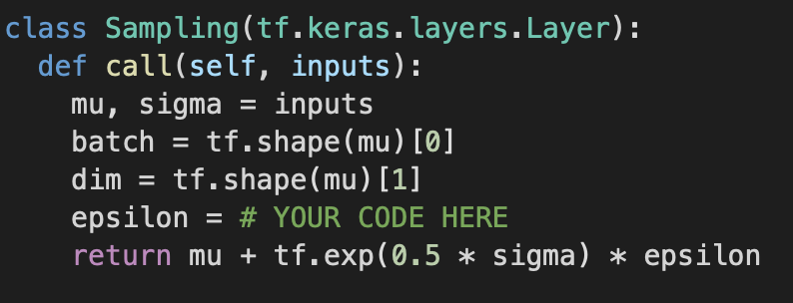

**1 / 1 point**

tf.keras.backend.random_normal(shape=(batch, dim))

**Correct**

Correct!

**3.**

**Question 3**

When building the architecture for the decoder for a *convolutional Variational AutoEncoder*, what type of layers will you use ? Below is a screenshot of the code with # layer name # written in place of the actual layer that you would use. What goes in place of # layer name #?

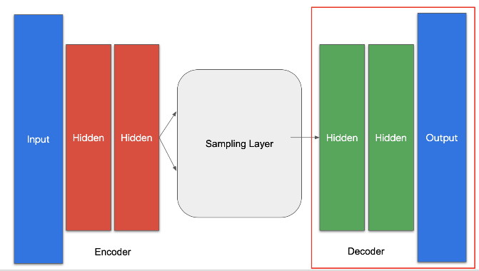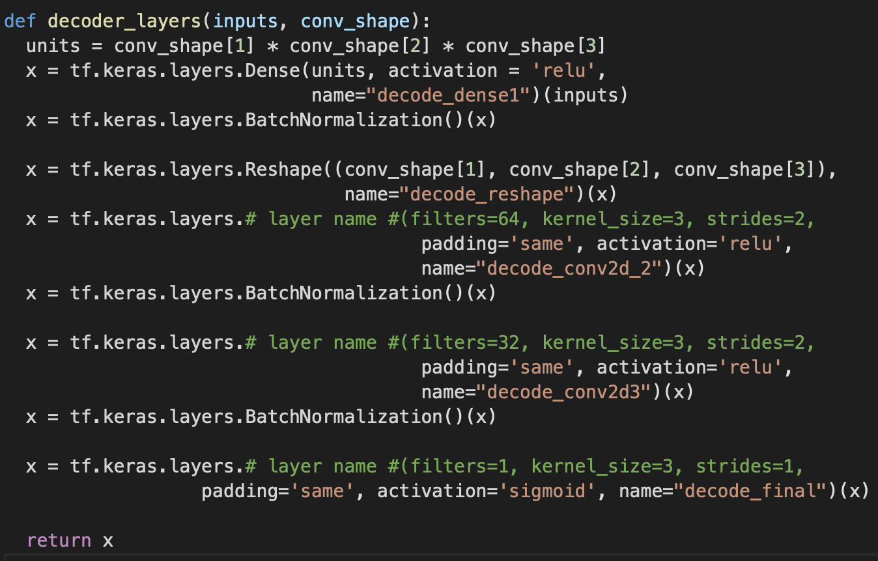

**1 / 1 point**



Conv2DTranspose

**Correct**

Correct! This will help you invert the convolutional filters applied during encoding.

**4.**

**Question 4**

Fill in the missing code for Kullback-Leibler cost function.

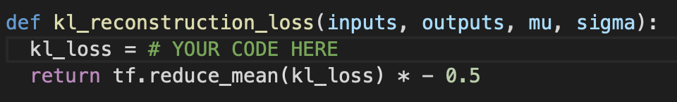

**1 / 1 point**



kl_loss = 1 + sigma - tf.square(mu) - tf.math.exp(sigma)

**Correct**

Correct!